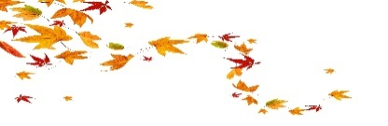
November 2022
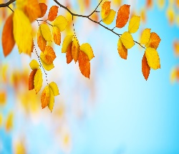 | 1.  All saint’s day/  Music reminiscence | 2.  Music with Kevin/  Virtual travel | 3.  Arts and craft/  Hairdresser/  Bon Fire Night  In Springkell | 4.  Small animal  visit/ | 5.  Guy Fawkes night | 6.  Discuss the news | 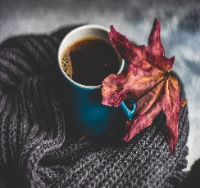
7.  Skittles/  Bingo | 8.  Music with Kevin/  Memory games | 9.  Village walk/  Physio | 10.  Art and craft/  Hairdresser | 11.  Variety and Quiz with Ava/  Remembrance Day | 12.  Manicure and hands spa | 13.  Remembrance Sunday | 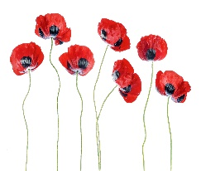
14.  Chair exercise/  Bingo | 15.  Floor games/  Happy hour | 16.  Music with Kevin/  Physio | 17.  Sensory quiz/  Hairdresser | 18.  C of England service/  Film afternoon | 19.  Manicure and hands spa | 20.  Discuss the news | 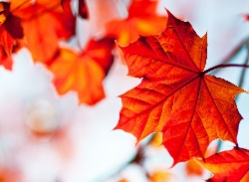
21.  Skittles/  Bingo | 22.  Foot care/  Physio | 23.  Village walk/  Table games | 24.  Arts and craft/  Hairdresser | 25.  Board games/  Manicure and hands spa | 26.  Music with Stephen | 27.  1st Sunday in Advent | 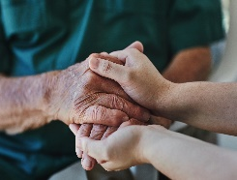
28.  Chair exercise/  Bingo | 29.  Floor games/  Happy Hour | 30.  Music with Kevin/  St Andrew’s day | 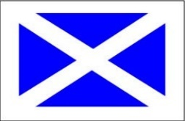  This Photo by Unknown Author is licensed under CC BY-SA-NC |  | 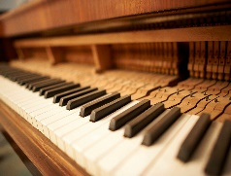 | 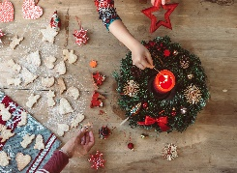 | 