· December 2022 ·
This Photo by Unknown Author is licensed under CC BY-NC
∙ Monday ∙ | ∙ Tuesday ∙ | ∙ Wednesday ∙ | ∙ Thursday ∙ | ∙ Friday ∙ | ∙ Saturday ∙ | ∙ Sunday ∙
November Winners:  Winner of - ‘How Many Leaves in the jar?’- Barbara  Ray drew winner for ‘Lucky Door Prize’ - Lorraine  Well Done everyone for taking part. |  |  | 1  10am Carol Concert – Ballard School  2pm Relaxing in lounge with Christmas music | 2  10:30am Christmas Craft – Wreaths  This Photo by Unknown Author is licensed under CC BY-NC-ND  2pm A Little Light Entertainment -Paul -Singer | 3  One to One Room visits & music in lounge | 4  2pm Nail Care  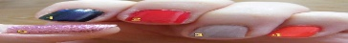
5  Hairdresser  11:15am G Fitness Antony  2pm Art & Craft  Finish Jigsaw Christmas Tree | 6  Mulled Wine &  Mince Pie Afternoon 2:30 till 4:30pm  2:30pm Simon – Plays the Keyboard  This Photo by Unknown Author is licensed under CC BY-NC | 7  11am Nail Care & Mobile Shop  2pm Play Your Cards Right  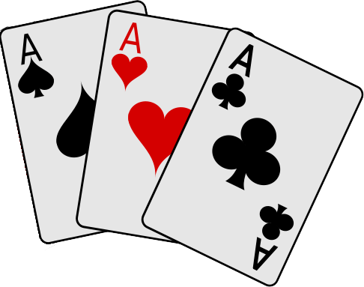  This Photo by Unknown Author is licensed under CC BY-NC | 8  11am - Art & Craft  Finish Table Decorations  This Photo by Unknown Author is licensed under CC BY-NC-ND  2pm Quiz | 9  11am Resident’s Meeting –  Reveal: ‘Colouring contest’ and ‘lucky door prize’ Christmas winners.  2:15pm Nicole - Singer | 10  One to One Room visits & music in lounge | 11  2pm Nail Care
12  11am Physical Games  2:30pm Chaplin (Christine) Visits | 13  11am Table Games  2pm | 14  11am Nail Care & Mobile Shop  2pm Reminiscing Christmas  This Photo by Unknown Author is licensed under CC BY-NC | 15  11am Nick Sellers - Singer  2pm Quiz | 16  11am Christmas Colouring / painting  & Music in the lounge  2pm Christmas Movie  And Choc Ices | 17  One to One Room visits & music in lounge | 18  11am Nail Care  2:15 Tony Sings for you
19  Hairdresser  11:15am  G Fitness Antony  2pm Famous Faces & reminisce | 20  2:15pm Christmas Party  2:30pm  Retro Rita-Singer  3:30pm Finger Food  This Photo by Unknown Author is licensed under CC BY-NC | 21  11am Nail Care & Mobile Shop  1:45pm Christmas Quiz  2:30pm Carol Service with Anna Chaplain | 22  11am Brighter Days Motivational Therapy – Simon  2pm Christmas Reminisce / Sing A Long | 23  10:30am Baking Mince Pies  2:15pm Christmas – Stories & Reveal ‘How Many Pom Poms in the jar’  This Photo by Unknown Author is licensed under CC BY-NC | 24  Christmas Jumper Day  One to One Room visits  1:30pm Christmas Film-  White Christmas  Sherry and nibbles  This Photo by Unknown Author is licensed under CC BY-NC | 25  .  MERRY CHRISTMAS
26  11am Physical Games  2pm Boxing Day | 27  11am Table Games  Afternoon – Relaxing music in the lounge and One to Ones | 28  11am Nail Care & Mobile Shop  Afternoon –  Wildlife Documentary | 29  11am Nick Sellers - Singer  2pm Quiz | 30  11am Christmas Reminisce  2pm Play Your Cards Right  This Photo by Unknown Author is licensed under CC BY-NC | 31  New Year’s Eve  Room Visits &  Music in Lounge  1:30pm Festive Film  Sherry and nibbles  This Photo by Unknown Author is licensed under CC BY-NC

